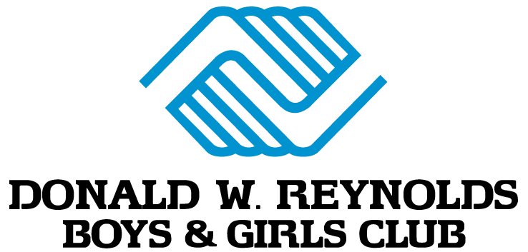
As of 9/11/2020

COVID-19 Operational Procedures: EXTERNAL (After School)

Entry/Drop Off/Pickup
- We will be walking (bussing in bad weather) kids over from Owl Creek daily at the end of the school day. Once we get to the Club, members will be directed to their assigned areas.
- If you are dropping off a member from a different school, please pull into the circle drive and call 479-442-9242 and press * and a staff member will come greet you and get your child to their designated area.
- All members will be temperature checked as we arrive to club or as they are dropped off and will be required to wash hands.
- We will also provide hand sanitizer for all persons entering the building.
- Pick-up: by 6:00 (at front circle drive; please call 479-442-9242 and press * for the reception desk)
  - Parents are encouraged to have the same designated authorized person drop off and pick up the child every day. If possible, older people such as grandparents or those with serious underlying medical conditions should not pick up children, because they are more at risk for severe illness from COVID-19.
- All visitors and volunteers are not allowed in our building without prior approval.
- We ask that members not bring personal items from home with the exception of a swimsuit, towel, and/or their backpack from their school day, which will be placed in designated homeroom and left there until appropriate times.
- Families will be required to sign a waiver indicating understanding of COVID-19, its symptoms and possible complications, and release of liability if allowing child to attend.

Staff
- Staff must enter through the front entry and directly wash hands.
- Staff will have their temperature and symptoms checked and sent home if fever over 100 degrees or if they display concerning symptoms of COVID-19.

Bathrooms
- We will require one member at a time in the restrooms and schedule hand cleaning breaks.

Gym/Outside/Playgrounds
- Only 1 group at a time, in the same area, will be scheduled for outside time. Each area will have their own equipment and will be responsible for cleaning and sanitizing after they leave the space.
- Only 1 or 2 groups at a time will be scheduled for gym time. Each area will have their own equipment and will be responsible for cleaning and sanitizing after they leave the space.

Snacks
- Members will receive an afternoon snack.
- All snacks will be eaten in homeroom areas, not in any common space. Snacks will be served by staff members and no family style dining will be allowed.

Group Size
- We intend to limit group size to up to 15 children and 1 staff.
- Members will remain in groups throughout the day, having the same room daily as their homeroom as well as rotating to different stations/areas. Each area will be sanitized before rotating (door knobs, tables, chairs, equipment, etc.) as well as each child using hand sanitizer.

Masks
- All youth are required to wear a face covering. The policy provides for exceptions, such as for eating and drinking, during certain outside activities, when social distancing measures are in place, and in specific instructional needs as determined by the staff.

Field Trips
- We will not be participating in any field trips until further notice.

Programs
- We will continue to offer meaningful, intentional programs that focus on healthy lifestyles, character and leadership, and academic success which engages members and promotes fun.

Expectations
- Club members must do their best to follow all expectations. Failure to do so can result in removal from our program. Traditional Club expectations apply and COVID-19 related expectations are below:
  - Club members will be encouraged to remain 6 feet apart at all times. Staff members will do their best to ensure this happens, but we ask that parents/guardians remind their members of this rule.
  - Club members will participate in regular, scheduled hygiene practices to ensure safety.

Cleaning and Sanitation
- We will have a detailed cleaning and sanitization schedule to ensure proper safety. Cleaning and disinfecting will occur with all toys, materials, equipment and surfaces daily. Additionally, we will have a staff member dedicated to cleaning frequently touched surfaces such as door handles, light switches, etc. throughout the program.

Communication
- Please communicate any changes in family health circumstances as quickly as possible so that we may mitigate any issues that may arise. We will commit to communicating as much information as possible as often as possible.

Positive COVID-19 Case
- In the event that a Club or staff member is considered a direct contact by the local health department with an individual that has tested positive for COVID-19:
  - Club or staff member would be mandated to self-quarantine for up to 14 days.
  - Operations would remain normal with screening and cleaning processes continuing daily.

- If someone in our buildings tests positive for COVID-19:
  - All Club families and staff, the Washington County Health Department, and BCGA will be notified.
  - We will immediately send home or separate anyone who becomes sick.
  - Work in collaboration with your health department to determine when to re-open closed areas and when staff in quarantine may be allowed to return to work. This could be up to a 14 day quarantine for everyone involved with the program.
  - After re-opening, continue regular cleaning, disinfection, social distancing, and hygiene practices.
Changes
- The COVID-19 situation is fluid and we reserve the right to adjust policies and procedures as needed to maintain the health and safety of children and staff. We will communicate any changes with families.

